# **Duct Tape Prints as an Imagemaking Technique**

## **We All Love Duct Tape**

How is duct tape like the force from Star Wars? It has a light side, a dark side, and it holds the universe together.

That joke has probably been circulating since the first Star Wars film opened in theaters, but in many ways, it highlights our love of **duct tape**. The strong, versatile substance was originally designed and marketed to help seal the ducts of heating and cooling systems, but it quickly expanding beyond its original use.

| tape  ***Duct tape has a wide following for its versatility in repairs and in artwork.*** |
| --- |

Even before manufacturers started releasing duct tape with an infinite variety of colors and patterns, people began experimenting with the simple, silvery adhesive. While we cannot even begin to recount the number of ways people have used duct tape, including making prom attires out of it, we can discuss some fascinating ways to use duct tape in graphic design.

## 

## **Printing with Duct Tape**

To use duct tape as a print template, you first need a smooth surface, like plastic, so you can easily remove the tape. Cut and press a piece of tape to this surface. Next, you can use a pen knife to cut out the shapes you want to print.

Peel these back from your plastic surface and affix them to a piece of paper in whatever arrangement you desire. With a small sponge or cloth, apply an oil-based stamp ink to the surface with the duct tape. The ink will soak into the paper but remain on the surface of the tape.

Finally, set another piece of paper on top of the piece with the duct tape and ink. Hold it securely so it does not slide, and begin to press and rub it firmly. You will need enough pressure to force the ink onto your paper. Peel back your paper and look at your new print.

You can also change the ink color and print again, adding another color and a new dimension to your project. You can even take the page with the print and use a different duct tape template to add additional shapes. Basically, you are only limited by your imagination.

## **Duct Tape Texture**

You can also use duct tape to give your work a textured appearance. One method is to make a **rubbing**, a technique of moving a pencil, crayon, chalk, or charcoal over a paper's surface to form an image from the raised and depressed areas of an object underneath.

***Grave rubbing involves going over a depressed area, instead of a raised area like duct tape would supply.***

|  |
| --- |

Repeat the previous steps of cutting out shapes from your duct tape. With that, you can either leave it on your cutting surface to rub or arrange several shapes on the surface or a separate piece of paper. As your medium encounters the raised surfaces and edges of your tape shapes, it will make a darker, thicker, or more noticeable mark.

## **Other Tape Creations**

Duct tape isn't the only adhesive used in graphic design projects. **Max Zorn**, a renowned tape artist from Amsterdam, uses transparent packaging tape. By layering the strips, he creates areas of shading in a monochrome (single color) design of brown ranging from pale amber to black coffee. He even did a stunning recreation of Vermeer's *Girl with a Pearl Earring*.

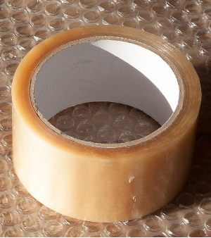

***Max Zorn uses packaging tape like this in his creations.***